HomeWork 1

Name: Muhammad Shaheer

Roll no :20p-0480

Subject :Data structure

Question No1:_____________________________________?

Code:

#include<iostream>

using namespace std;

int main()

{

    const int m = 6,n=6;

    int arr[m][n];

    for(int i = 0;i<m;i++)

    {

        for(int j=0;j<n;j++)

        {

            cout<<"Enter elements"<<endl;

            cin>>arr[i][j];

        }

    }

    for (int i = 0; i < m; i++)

    {

        for(int j=0;j<n;j++)

        {

            cout<<"You entered"<<endl;

            cout<<arr[i][j]<<" ";

        }

        cout<<endl;

    }

    cout<<endl;

    //for matrix 2

    const int a = 6,b=6;

    int arr2[a][b];

    int result1,result2,result3;

    int sum;

    int n1,n2,n3;

    n1=arr[1][1];

    sum=arr[0][0]+arr[0][1]+arr[0][2]+arr[1][0]+arr[1][2]+arr[2][0]+arr[2][1]+arr[2][2];

    result1=sum/n1;

    sum =0;

    n2=arr[4][5];

    sum=arr[3][4]+arr[3][5]+arr[4][4]+arr[5][4]+arr[5][5];

    result2=sum/n2;

    sum =0;

    n3=arr[5][0];

    sum=arr[4][0]+arr[4][1]+arr[5][1];

    result3=sum/n3;

    cout<<" 1st result ="<<result1<<endl;

    cout<<" 2nd  result ="<<result2<<endl;

    cout<<" 3rd result ="<<result3<<endl;

    for(int i = 0;i<a;i++)

    {

        for(int j=0;j<b;j++)

        {

            cout<<"Enter elements"<<endl;

            cin>>arr[i][j];

        }

    }

    for (int i = 0; i < a; i++)

    {

        for(int j=0;j<b;j++)

        {

            cout<<"You entered"<<arr[i][j]<<endl;

            cout<<arr[i][j]<<" ";

        }

        cout<<endl;

    }

    cout<<endl;

    return 0;

}

Output:

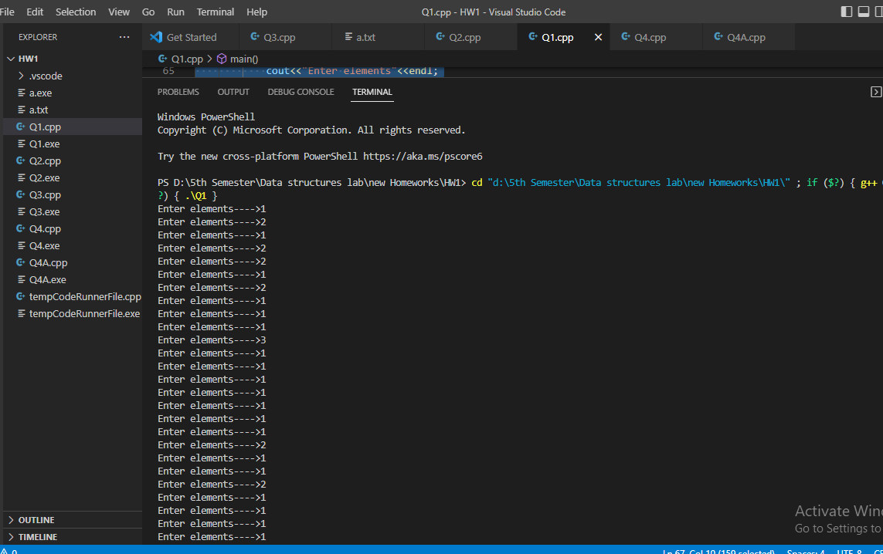

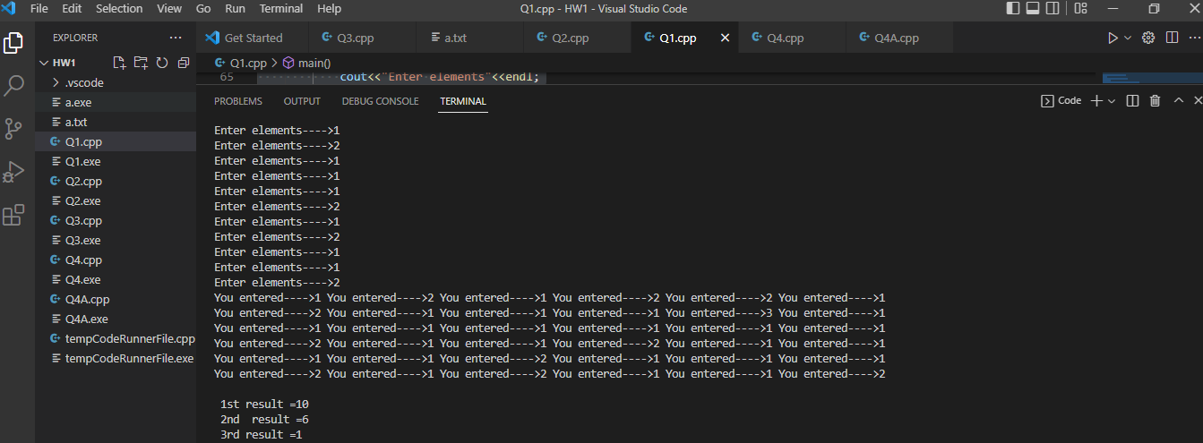

Question no2:______________________________________?

Code:

#include<iostream>

using namespace std;

void Table(int *p,int *ptr)

    {

        for(int i=1; i<=*ptr; i++)

    {

        cout<<*p<<"*"<<i<<"="<<(*p) *i<<endl;

    }

    }

int main()

{

    int n;

    int lim;

    int *p;

    int *ptr;

    cout<<"Enter table number: "<<endl;

    cin>>n;

    cout<<"Enter table  limit"<<endl;

    cin>>lim;

    p=&n;

    ptr =& lim;

    // cout<<*lim;

    // int result = *n * i;

    Table(p,ptr);

}

Output:

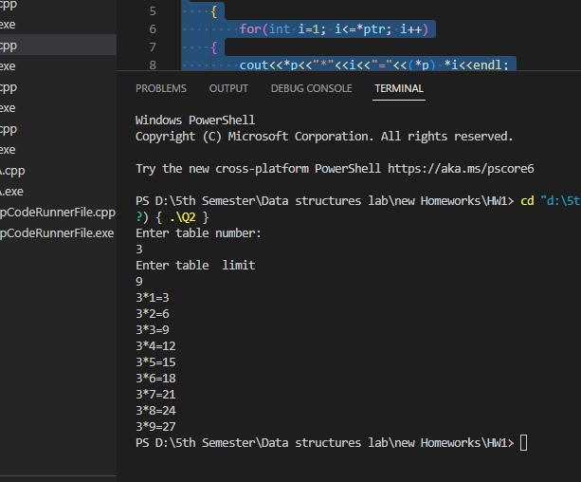

Question No3:_____________________________________?

Code:

#include<iostream>

#include<fstream>

using namespace std;

int main()

{

    const int m = 5,n=5;

    int arr[m][n];

    ifstream iFile;

    iFile.open("a.txt");

    //this part is use for reading data from file which i store in the same file

    for(int i = 0;i<m;i++)

    {

        for(int j=0;j<n;j++)

        {

            iFile>>arr[i][j];

        }

    }

    iFile.close();

    //this part is used for printing data from file

    cout<<"your 2D arrray is :"<<endl;

    for (int i = 0; i < m; i++)

    {

        for(int j=0;j<n;j++)

        {

            cout<<arr[i][j]<<" ";

        }

        cout<<endl;

    }

    cout<<endl;

    //this part is used for calculating sum of 2D array

    int array2[m];

    for (int i = 0; i < m; i++)

    {

        array2[i]=0;

    }

    cout<<"sum of 2D array is:"<<endl;

    for (int i = 0; i < m; i++)

    {

        for (int j = 0; j< n; j++)

        {

            array2[i]=array2[i]+arr[i][j];

        }

    }

     for (int i = 0; i < m; i++)

    {

        cout<<array2[i]<<" ";

    }

    return 0;

}

Output:

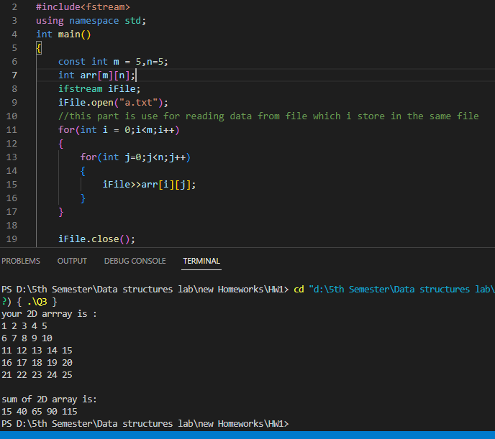

File.txt:

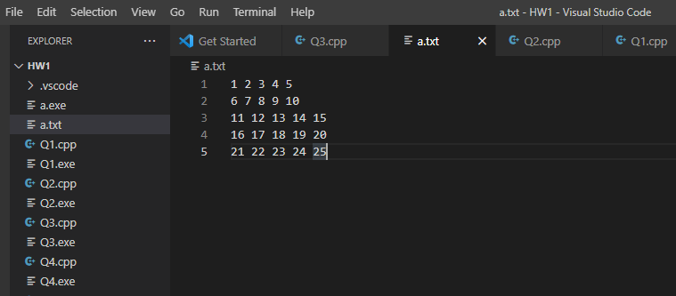

Question no 4:______________________________________?

Code:

#include<iostream>

using namespace std;

void password_Validator(string& password)

{

    int n = password.length();

    bool hasLower = false, hasUpper = false, hasDigit = false;

    for (int i = 0; i < n; i++) {

        if (islower(password[i]))

            hasLower = true;

        if (isupper(password[i]))

            hasUpper = true;

        if (isdigit(password[i]))

            hasDigit = true;

    }

    cout << "The password you  entered is :";

    if ( hasUpper && hasDigit && hasLower && (n > 5)&&(n<11))

        cout << "password validated succesfully" << endl;

    else if ((hasLower || hasUpper) && hasDigit && (n >5)&&(n<11))

        cout << "Normal" << endl;

    else

        cout << "your password is weak" << endl;

}

int main()

{

    string password;

    cout <<"Enter your password"<<endl;

  getline(cin,password);

    password_Validator(password);

    return 0;

}

Output:

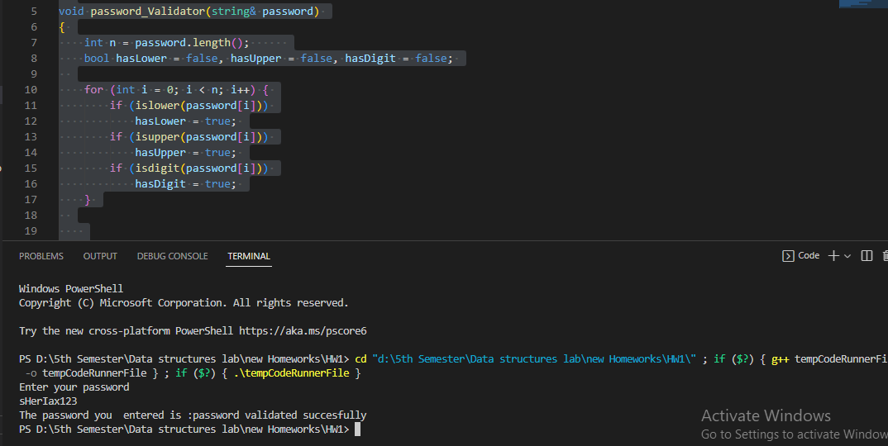

Question no 4(b):___________________________________?

Code:

#include <iostream>

#include <regex>

#include <string>

#include <cctype>

using namespace std;

bool Email_validator(string email)

{

    const regex pattern("(\\w+)(\\.|_)?(\\w*)@(\\w+)(\\.(\\w+))+") ;

    std :: string Email_validator = "[_a-z0-9-]+(.[_a-z0-9-]+)*@[a-z0-9-]+(.[a- z0-9-]+)*(.[a-z]{2,4})";

;

    return regex_match(email, pattern);

}

int main()

{

    system("cls");

    cout << " Email Validation......."<<endl;

    string Email;

    cout << "Enter Your Email Account: ";

    cin >> Email;

    // bool valid=validate(Email_validator,Email)

    // {

    // }

    if (Email_validator(Email))

    {

        cout << "...............Your Email Account is Valid.............." << endl;

    }

    else

    {

        cout << "...............Your Email Id is Invalid.................." << endl;

    }

    return 0;

}

Output:

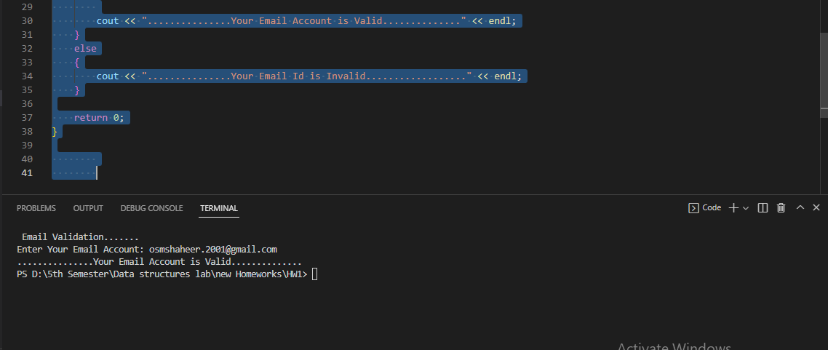

The End:_________________________________________